FOR IMMEDIATE RELEASE

APAS Hosts "New Energy Summit 2024 –
Powering Tomorrow: Exploring the Frontiers of New Energy"
Partnering with the Industry to Ignite the New Energy Innovation
and Explore New Trends in Green Technology

(Hong Kong, 3 October 2024) The Automotive Platforms and Application Systems R&D Centre (APAS) held its annual flagship event, "New Energy Summit 2024 - Powering Tomorrow: Exploring the Frontiers of New Energy", today at the Hong Kong Productivity Council Building. The event brought together industry elites from home and abroad to discuss future trends in new energy, share the latest technological advancements and business opportunities, and delve into cutting-edge developments in sustainable and renewable energy technologies, promoting the robust development of the new energy industry. During the event, APAS celebrated it is new opening of New Energy Hall, and signed Memorandums of Understanding (MoUs) with three local utility companies, universities, and research partners to further strengthen technical exchange and cooperation in the field of new energy.

In his welcome speech, Dr Lawrence CHEUNG, CEO of APAS, said: “APAS is fully committed to supporting the Government's policies and promoting the development of new energy technologies and innovations, including hydrogen. We are also thrilled to collaborate with Hong Kong Towngas, The Hong Kong Polytechnic University, and Templewater, joining hands on future research and technical advancement to promote the development of upstream and downstream supply chain in new energy industry. Through partnerships with industries, academia, and technical institutions, our goal is to propel green transportation and smart mobility initiatives, facilitating Hong Kong's transformation into a sustainability-conscious green smart city."

APAS signed a MoU with The Hong Kong & China Gas Co. Ltd, committing to jointly bringing practical applications and best practices of new energy and sustainable development to Hong Kong and raising public awareness in this aspect. Additionally, APAS signed a MoU with The Hong Kong Polytechnic University to promote interdisciplinary research and development in the field of electric vehicles, combining expertise in engineering, technology, and environmental science. This collaboration aims to provide a platform for educating and training the next generation of engineers and researchers, equipping them with the critical skills needed for a sustainable future. APAS also signed a MoU with Templewater, a private equity firm that indirectly owns approximately 30% of Hong Kong’s public transport holding company, Bravo Transport Services Limited, and holds a stake in new energy vehicle producer and manufacturer, Wisdom Motor. This collaboration aims to foster cross-disciplinary research and application of new energy vehicles within the industry and investment community, and to jointly advance the sustainable development of green hydrogen energy transport in Hong Kong.

The event featured multiple keynote speeches by industry experts from home and abroad, covering the application and future development of alternative energies including hydrogen energy. Two panel discussions were held featuring "Exploring the Potential of Hydrogen as a Clean Energy Solution" and "Accelerating the Transition to Clean Energy: Opportunities, Challenges, and Strategies," providing in-depth analysis of the prospects and practical methods for current energy transitions. Over 300 industry professionals attended, sharing the latest developments and business opportunities in new energy, Hong Kong's carbon reduction policies, and the development of new energy vehicle markets in the mainland and internationally. They collectively explored the ways in addressing various challenges and opportunities in these new technologies.

Another highlight of the forum was the grand opening of the New Energy Hall, which epitomise APAS as a driver of automotive technology development in Hong Kong. The hall showcased the latest technological achievements and innovative applications, including a range of advanced new energy vehicle technologies and the latest developments in hydrogen fuel and other alternative energy vehicles. Participants experienced these advanced technologies firsthand and engaged in in-depth exchanges with researchers to understand the innovative concepts and practical applications behind the technologies.

The successful hosting of the New Energy Forum 2024 marks a new milestone in Hong Kong's R&D and application of new energy. APAS will continue to collaborate with various parties to promote the development of Hong Kong's new energy industry, contributing to the construction of a greener Hong Kong.

For more information APAS' services and projects, please visit the website: www.apas.org

- END -

Photo Captions:
- Dr Lawrence CHEUNG, Chief Executive Officer of APAS, Mr Yonghai DU, General Manager of APAS, and industry experts and leaders attended New Energy Summit 2024 – Powering Tomorrow: Exploring the Frontiers of New Energy joining hands with the industry to promote the development of the local new energy sector.
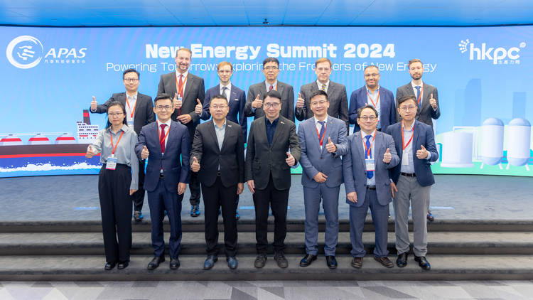
- Dr Lawrence CHEUNG (left), CEO of APAS, and Mr Sammy KONG (right), Assistant General Manager – Commercial and Industrial Marketing and Sales of The Hong Kong & China Gas Co. Ltd, signed a Memorandum of Understanding (MoU), committing to jointly raising public awareness of sustainability within the industry and community, and bringing practical applications and best practices of new energy and sustainable development to Hong Kong.
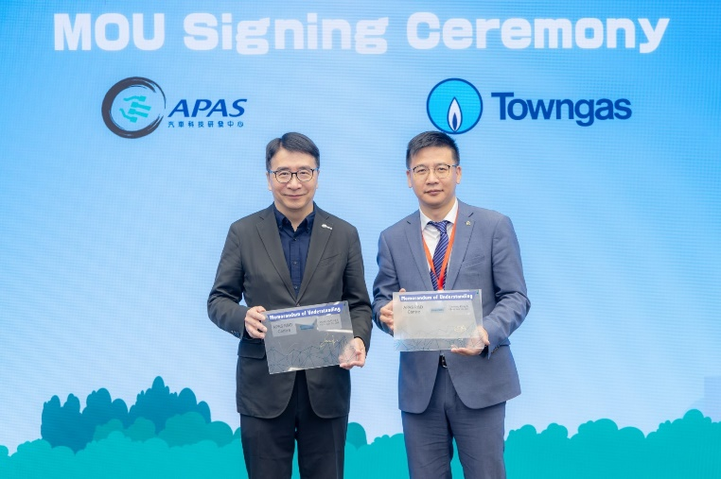
- Dr Lawrence CHEUNG (left), CEO of APAS, and Professor CHUNG Chi-yung (right) of The Hong Kong Polytechnic University, signed a Memorandum of Understanding (MoU) to deepen technical exchange and cooperation in research and development in the field of new energy.
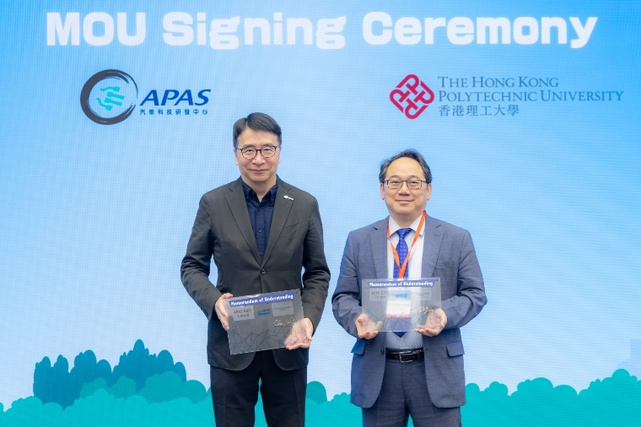
- Dr Lawrence CHEUNG (left), CEO of APAS, and Dr WAN Yufeng (right), Partner and Head of Carbon Neutral Investment at Templewater, signed a Memorandum of Understanding (MoU) to promote interdisciplinary research and development in the field of new energy vehicles. This collaboration aims to combine expertise in engineering, technology, and environmental science to push the boundaries of automotive innovation and explore limitless possibilities.
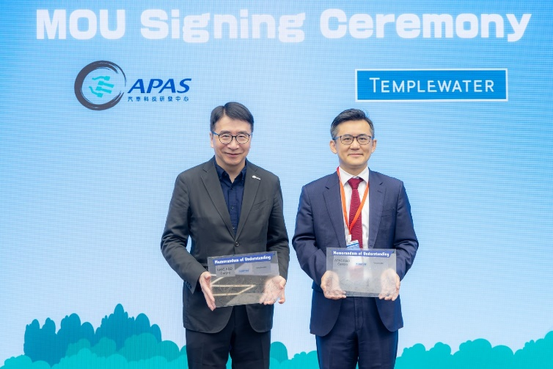
- The newly established New Energy Hall located in the Hong Kong Productivity Council Building showcases a series of advanced new energy vehicle technologies, including the latest developments in hydrogen fuel and other alternative energy models.
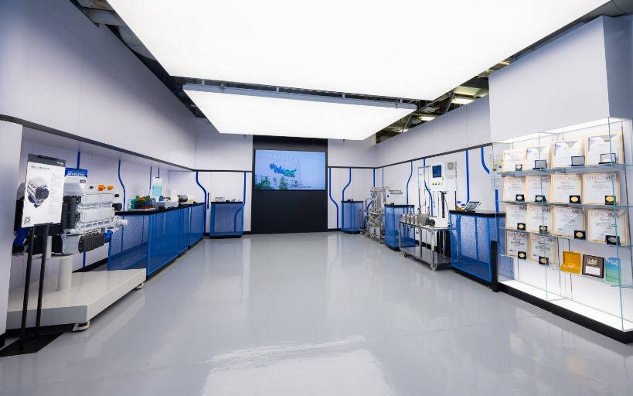

About the Automotive Platforms and Application Systems (APAS) R&D Centre
The Automotive Platforms and Application Systems R&D Centre (APAS) was established under the R&D Centre Programme of the Innovation and Technology Commission and is hosted by the Hong Kong Productivity Council (HKPC). APAS will be fully integrated under HKPC on 1 April 2025. The Centre continues to undertake market-led R&D programmes spanning green transportation, smart mobility, and intelligent systems, as well as commercialises R&D results in collaboration with industry, universities and technology institutes to enhance the competitiveness of Hong Kong's automotive and other transportation sectors.

About Hong Kong Productivity Council
The Hong Kong Productivity Council (HKPC) is a multi-disciplinary organisation established by statute in 1967, to promote productivity excellence through relentless drive of world-class advanced technologies and innovative service offerings to support Hong Kong enterprises. As a nationwide leader in innovative, market-driven research and development (R&D), specialising in leading technologies and all-rounded manufacturing services, HKPC promotes new industrialisation in Hong Kong and the Greater Bay Area and facilitates the development of new productive forces, leveraging innovation and technology (I&T), as well as bolstering Hong Kong to be an international innovation and technology centre and a smart city. The Council offers comprehensive innovative solutions for Hong Kong industries and enterprises, enabling them to achieve resources and productivity utilisation, effectiveness and cost reduction, and enhance competitiveness in both local and overseas marketplace. The Council partners and collaborates with local industries and enterprises and world-class R&D institutes to develop applied technology solutions for value creation. It also benefits a variety of sectors through product innovation, technology transfer, and commercialisation, bringing enormous business opportunities ahead. HKPC’s world-class R&D achievements have been widely recognised over the years, winning an array of local and overseas accolades.

In addition, HKPC offers SMEs and startups immediate and timely assistance in coping with the ever-changing business environment, and strengthens talent nurturing and Hong Kong’s competitiveness with FutureSkills training for enterprises and academia to enhance digital capabilities and STEM competencies.

For more information, please visit HKPC‘s website: www.hkpc.org/en.

Media Enquiry
Corporate Communications Unit
Corporate Development Division
Hong Kong Productivity Council
Tel: (852) 2788 5833
Email: mediacentre@hkpc.org


